MyMainScript 1
Your code here 1

MyMainScript
tic;

Your code here
myNumOfColors = 200;
myColorScale = [ [0:1/(myNumOfColors-1):1]' , [0:1/(myNumOfColors-1):1]' , [0:1/(myNumOfColors-1):1]' ];
k1=[0 1 0; 1 -4 1; 0 1 0];
k2=[-1 -1 -1; -1 8 -1; -1 -1 -1];
N=201;
f1=fftshift(fft2(k1,201,201));
f2=fftshift(fft2(k2,201,201));
figure();
imshow(log(1+abs(f1))), title('Kernel K1'), colormap jet, daspect ([1 1 1]), colorbar;
figure();
imshow(log(1+abs(f2))), title('Kernel K2'), colormap jet, daspect ([1 1 1]), colorbar;
figure();
surf(log(1+abs(f1))), title('Kernel K1');
figure();
surf(log(1+abs(f2))), title('Kernel K2');
figure();
imagesc(log(1+abs(f1))), title('Kernel K1'), colormap jet, daspect ([1 1 1]), colorbar;
figure();
imagesc(log(1+abs(f2))), title('Kernel K2'), colormap jet, daspect ([1 1 1]), colorbar;
toc;

DFT Visualization of Laplacian Kernels:
Each kernel performs a high pass filtering as they represent the derivative in 2D. Kernel K1 performs high pass filtering only along x and y directions whereas Kernel K2 performs high pass filtering along diagonals as well in addition to the x-y directions. Due to this reason, we can observe in the imshow plots that the contours of DFT are “squarish” for Kernel K1 and Circular for Kernel K2. For observing this more clearly, the imagesc plots are also provided. Also, we can see from the surf plots that the attenuation of low frequencies is direction specific whereas for Kernel K2, it is more or less symmetric along all directions.

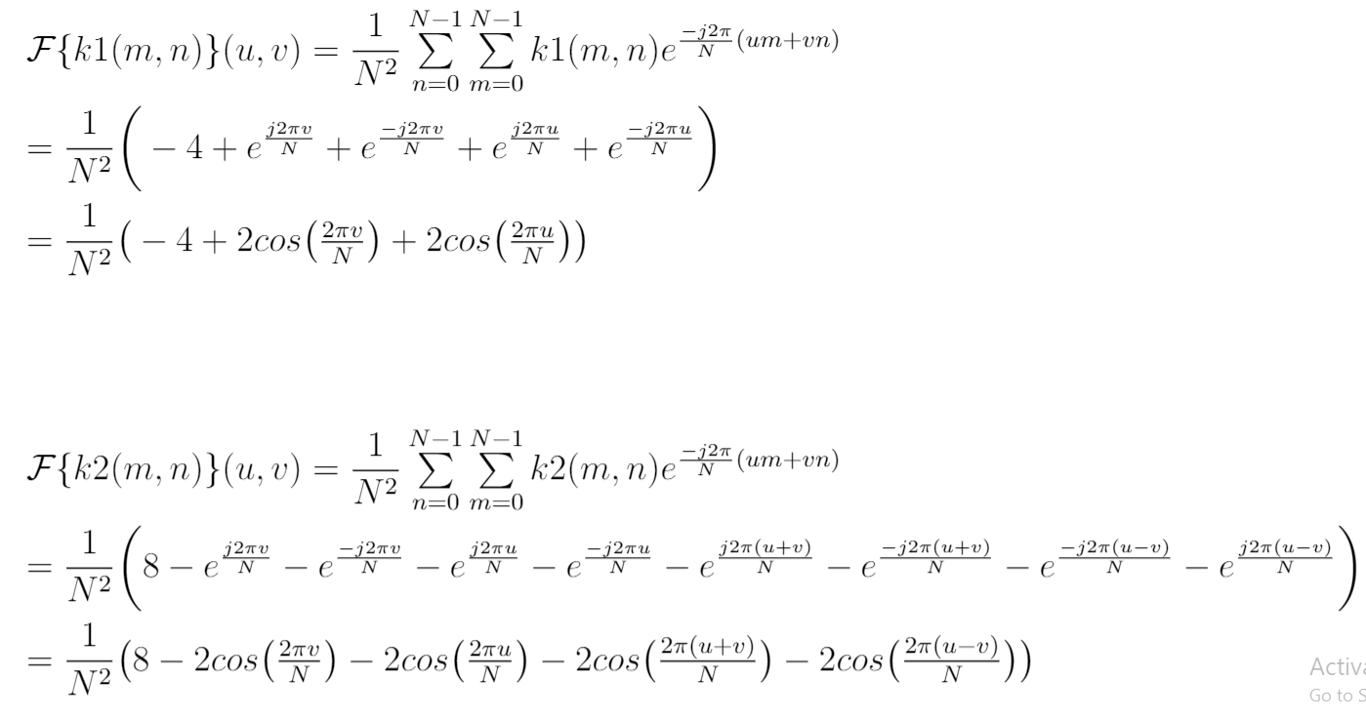

Plotted Using imshow():

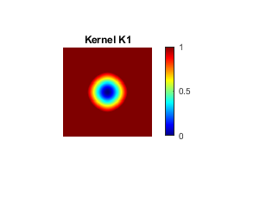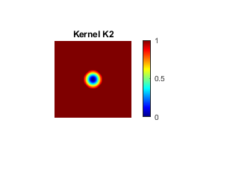
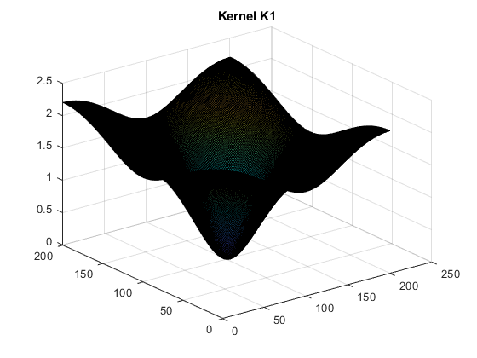
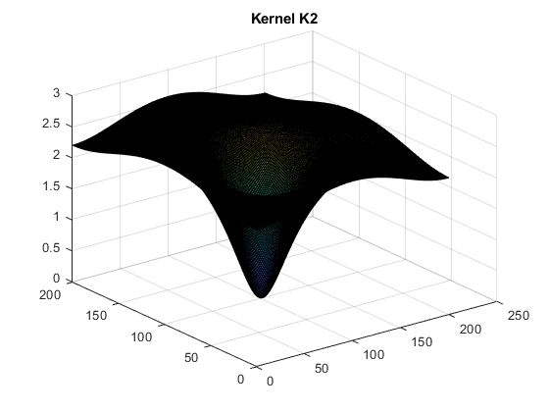

Plotted using imagesc():
